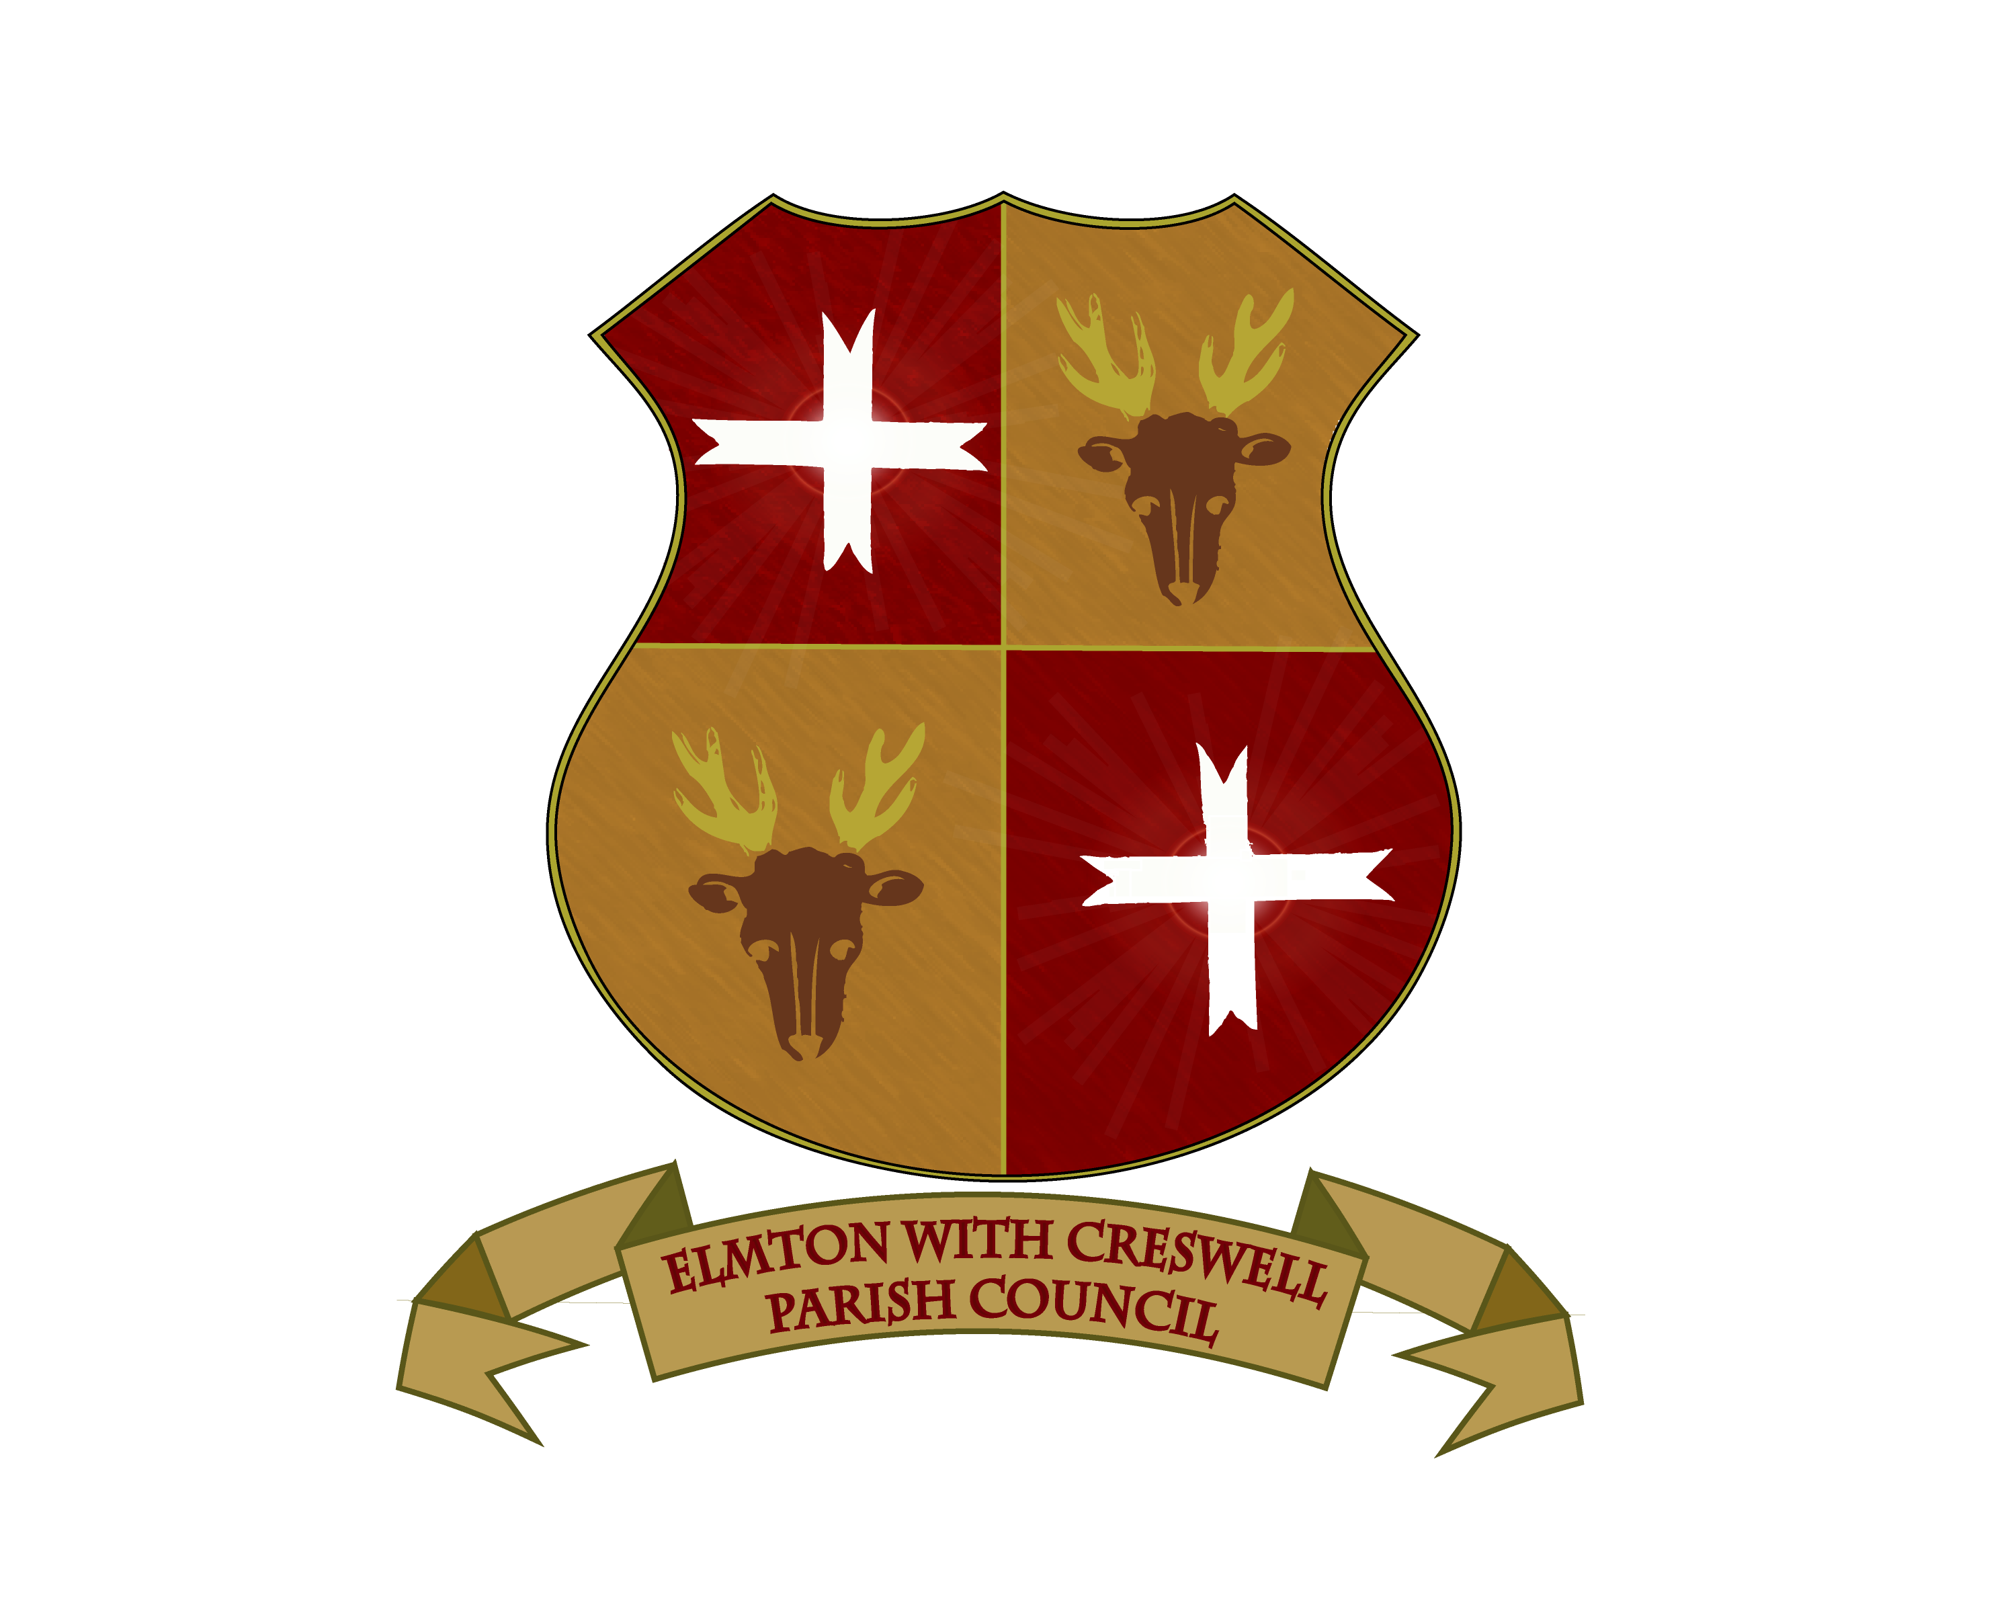

NOTICE OF MEETING
There will be a meeting of the Extraordinary Parish Council on
THURSDAY 12th December 2024 – 5:45pm
At Creswell Events Centre
MEMBERS OF THE PUBLIC AND PRESS MAY ATTEND

Signed
P Stothard
Clerk to the Council

