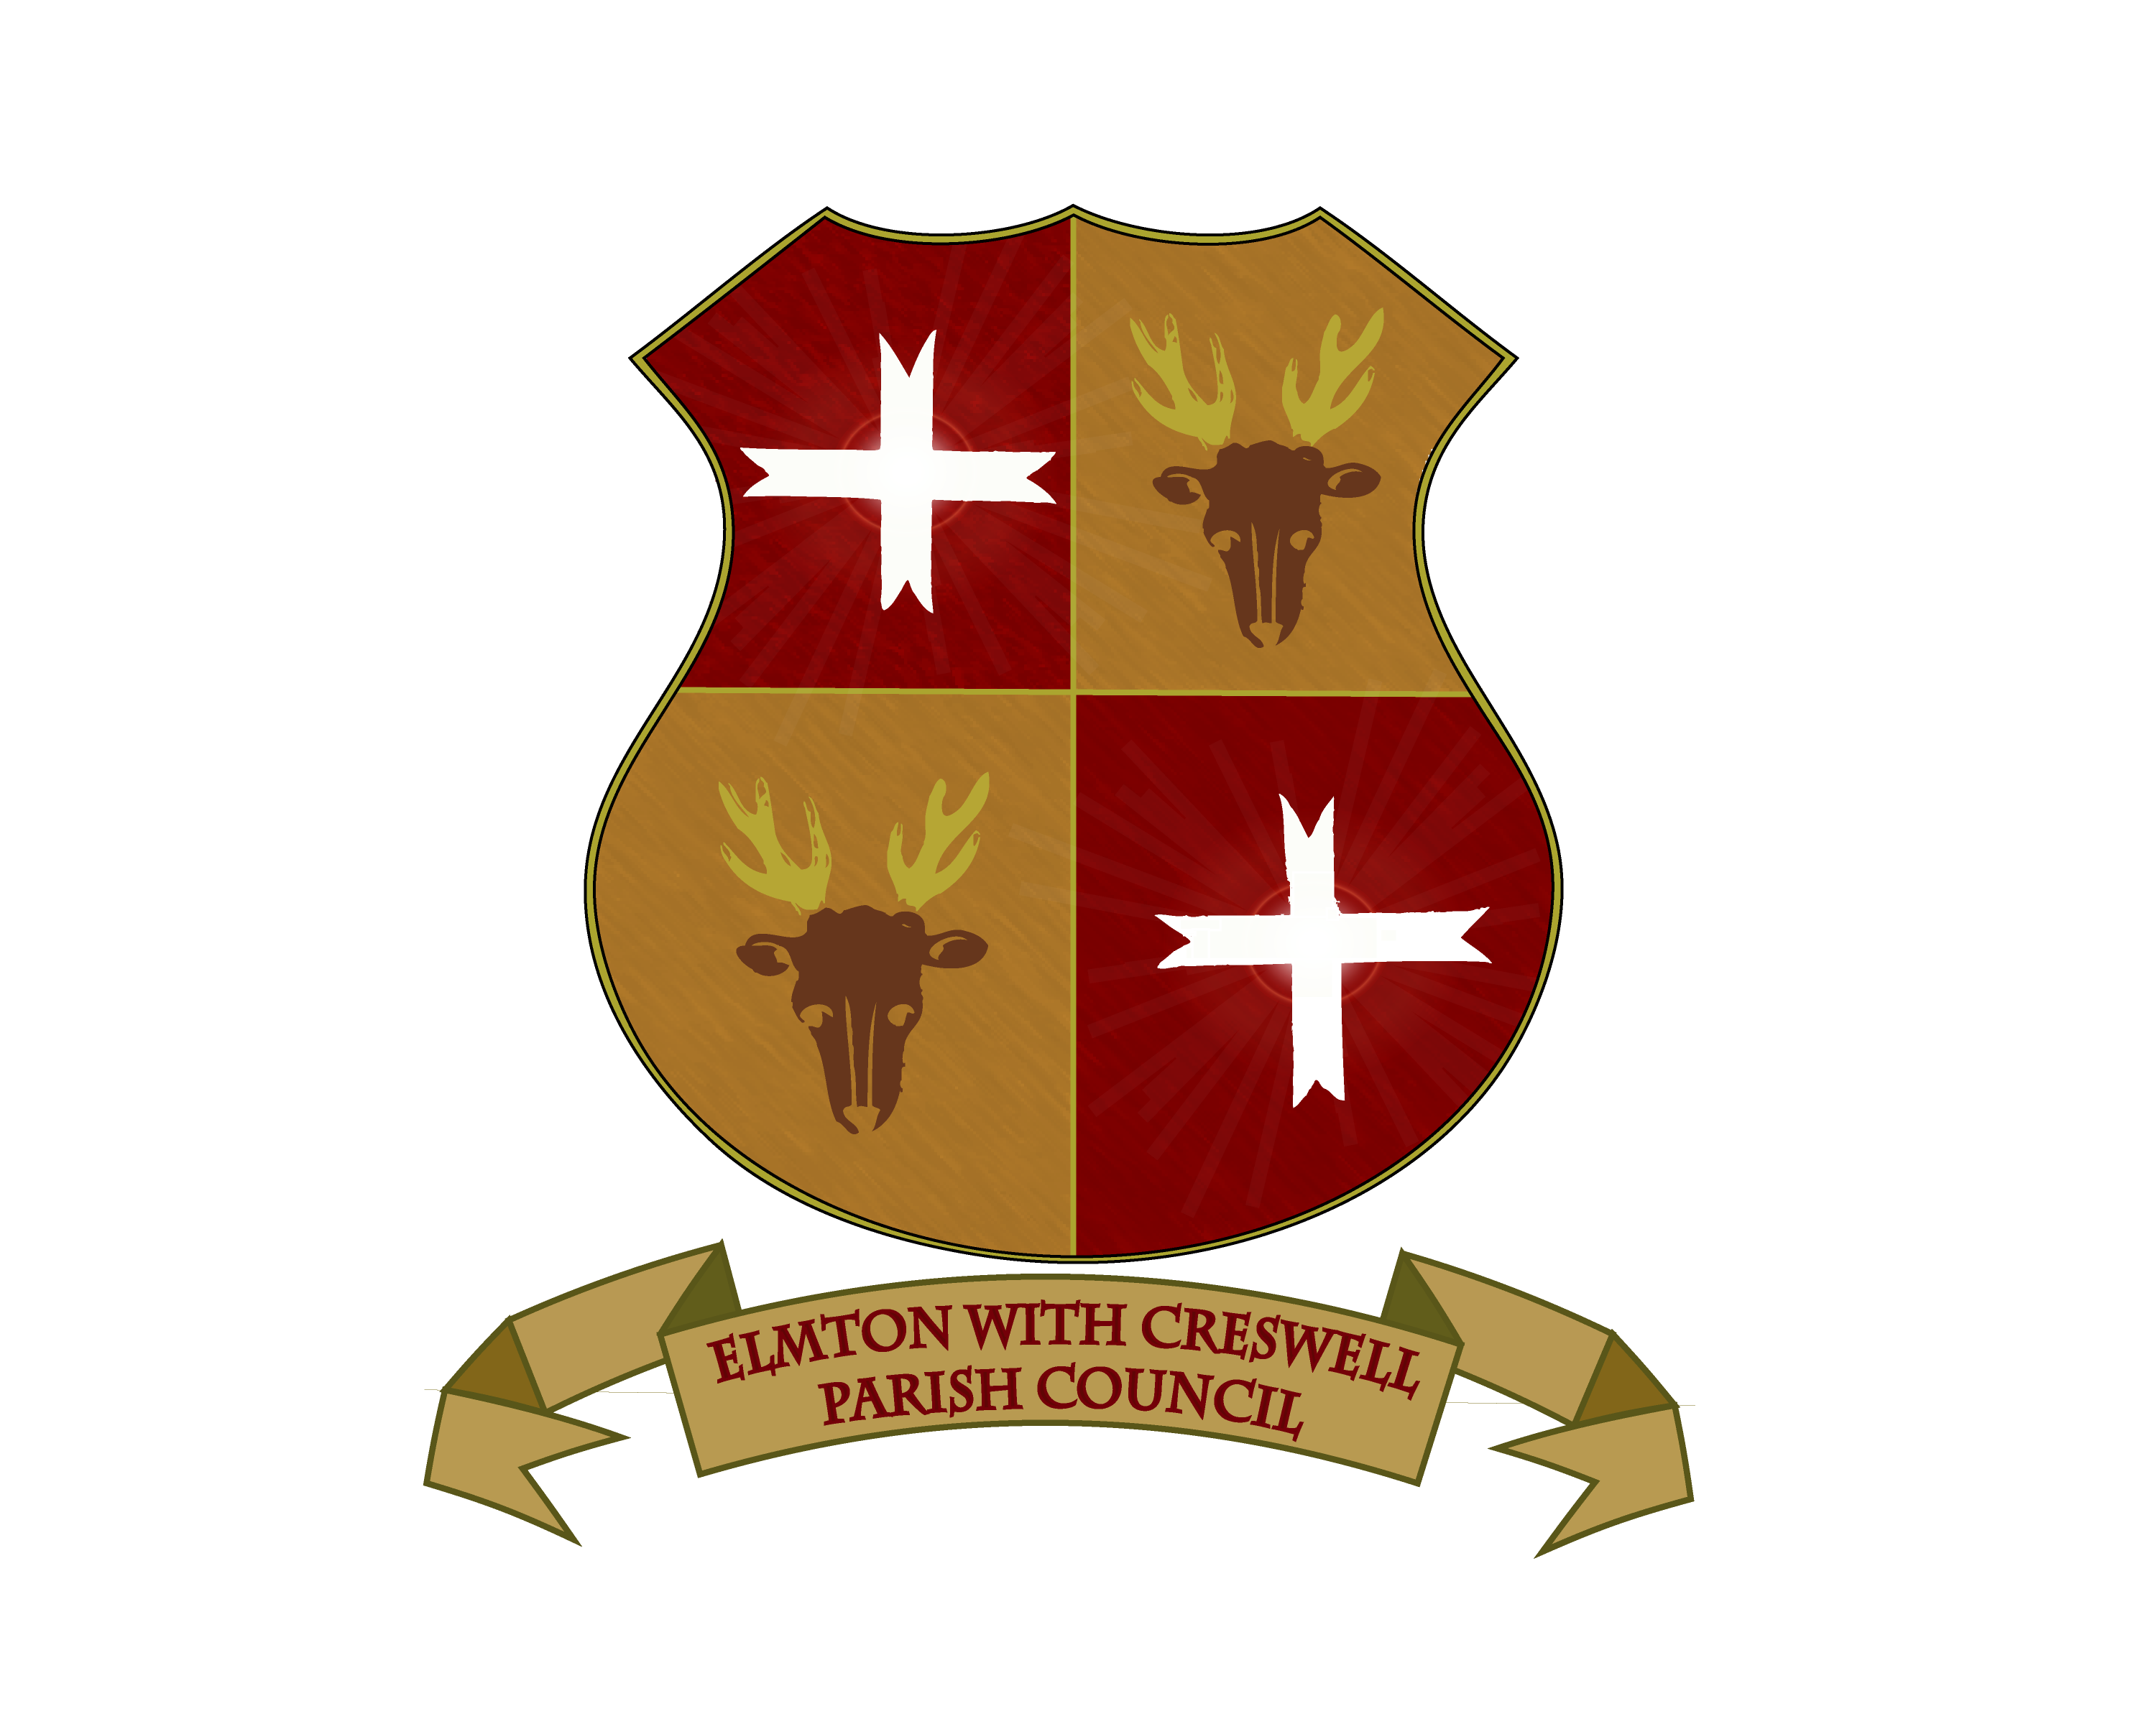

NOTICE OF MEETING

There will be a meeting of the Parish Council on
THURSDAY 23rd January – 5:45pm
At Creswell Events Centre

MEMBERS OF THE PUBLIC AND PRESS MAY ATTEND

Signed
Clerk to the Council

