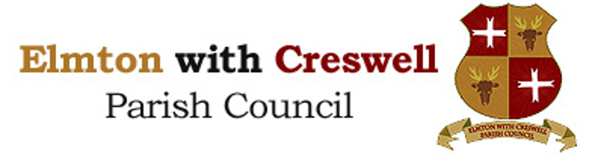

COMMUNITY ENGAGEMENT POLICY | ADOPTED SEPTEMBER 2026

Policy | Date & Minute
Adopted | 24.09.26 Min No 71/26 c
Reviewed
Review | Annually

The objectives of the policy are to;

- Encourage effective local community engagement.
- Ensure that the Council maintains a clear understanding of the need to engage with communities.
- Enable aspirations/comments/suggestions obtained from community engagement are considered by council.
- Support the Council to enhance its profile by improving engagement with the wider community in particular hard to reach groups.

Elmton with Creswell Parish Council advocates giving local people a voice and involving them in decisions which affect them and their community. This may include individuals, voluntary and community organisations as well as other public sector bodies. It provides opportunity for local people to talk to the Council about their aspirations and or needs in their community and neighbourhood. It allows the Council to inform people about what services it provides, how it prioritises, how policies are determined and how well it’s performing.

The key aspects of community engagement include:

- Clear and open communication to ensure that information is made accessible to all groups.
- Listening and understanding from a range of people to identify aspirations, needs and problems of local people and groups.
- Development of a network of relationships with individuals, voluntary and community groups, neighbouring Parish Councils and District and County Councils.

Effective and meaningful community engagement can provide a number of benefits:

- The problems and needs of local people are clearly identified in order that appropriate new or improved facilities /services can be provided.

- Those participating feel empowered by being involved in decision making in their local community. This may result in enhanced leadership and greater interest in elections and standing for council.

The Parish Council will facilitate community engagement in the following ways:

- Making information on what decisions are being considered and how residents can influence or contribute to the discussions in good time.
- Producing and publishing a list of annual meeting dates at the start of each maniple year.
- Communicating information via the Parish Council website, notice boards, posters, Facebook, consultations and word of mouth.
- Making all meetings of the Parish Council will be open to the public and press with a period set aside for residents to speak. The Parish Council website explains the procedure for residents wishing to speak at meetings.
- Residents can, where appropriate or necessary, make written reports/present petitions or have a case presented on their behalf to Councillors.
- Be open and accountable in its dealing with residents and the community.
- Make information on its policies and procedures freely available.
- Be receptive to requests from residents or communities and will attempt to be flexible in order to ensure their opinions are known. This may be by including an item for discussion on an agenda or allowing a local group to put their opinions into an official
report.
- When dealing with controversial issues that affect a particular community then consideration will be given to holding a public meeting.
- Promoting elections and the importance of the democratic process and the value of being a Councillor, and promoting the value to the parish of volunteering.

The Parish Clerk, Deputy Clerk and Clerical Officer are required to play neutral roles so that residents can be fully involved and be confident that they are receiving unbiased information and support. Details of how to contact the Parish Clerk/Office are displayed on notice boards and the Parish Council website.

